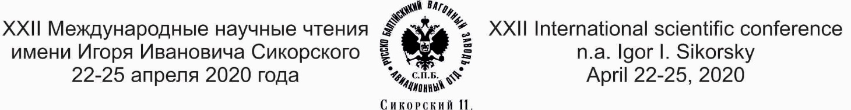

INFORMATION LETTER

Since 1999, International scientific Readings named after Igor Ivanovich Sikorsky have been held on the basis of the St. Petersburg State University of Civil Aviation.
Today, the Readings are a generally recognized forum for meetings, scientific and historical discussions and exchange of experience among representatives of the aviation community of Russia, near and far abroad-historians, scientists, aviation industry specialists, descendants of Russian aviators, students and schoolchildren.
The program of Readings includes: a plenary session; a joint meeting of aviation historians, museum workers and the club of descendants of Russian aviators; a section of students, schoolchildren, postgraduates and young scientists; a seminar on museum affairs; field events; a cultural program.
Aviation historians, scientists, researchers, descendants of Russian and foreign aviators, young scientists, postgraduates, students, representatives of civil aviation enterprises and related industries, representatives of scientific and educational institutions, museums, journalists, private individuals are invited to participate in the Readings – everyone who is interested in the history and modernity of Russian civil aviation, the prospects for its development.
In 2021, the XXIII International Scientific Readings named after Igor Ivanovich Sikorsky will be held from October 25 to 29.
If you agree to take part in the Readings, we ask you to send a completed application for a participant of the Readings no later than September 15, 2021. The application form is attached to this letter.
Participation in the Readings is free of charge. The costs of travel, accommodation and food are at the expense of the sending party.
Detailed information about the Readings is available on the websites www.spbguga.ru and www.aviamuseumspb.ru.

Contacts of the Organizing Committee of Readings: 196210, St. Petersburg, Pilotov str., 38, room 329. Phone/fax: (812) 704-15-20, e-mail: sikorskyspb@yandex.ru

